**Deep Web Domain Server**

Max vonBlankenburg - CS 355 – 12/4/2020

There are many sites on the internet that don’t have a public presence (i.e. sites that don’t show up in a Google search). A subset of these sites are tied to The Onion Router (TOR), an anonymous web browser. There are many reputable places where these sites can be found, but there is currently no search engine for them. The Deep Web Domain Server stores links and information for “.onion” domains and allows them to be searched and referenced, like a pseudo search engine. The server stores reputable link sources, links to domains themselves, and references that vouch for the authenticity of those domains. The server api allows keyword searches to be performed on these data as well as searches by source and reference. The api also supports adding new data to the server.

**USECASES**

Path Name: Sites Online

Path: /api/v1/sites

Description: Used to obtain a list of domains currently online and their data.

Example: curl <http://blue.cs.sonoma.edu:8229/api/v1/sites>

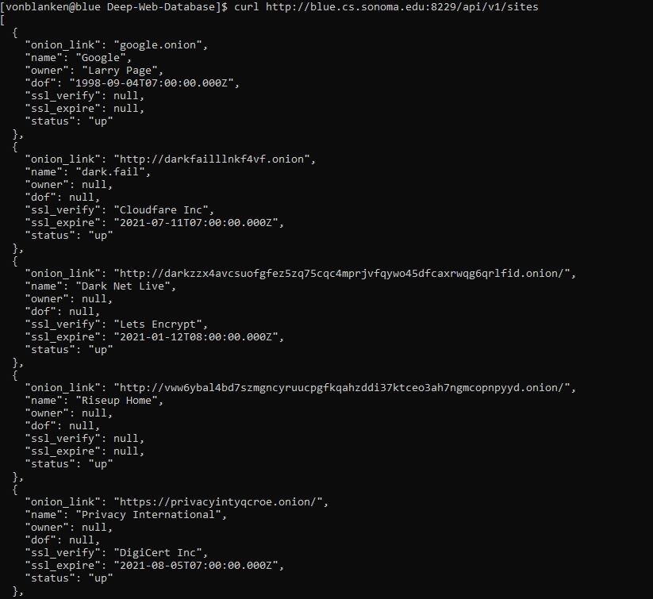

Path Name: Update Site

Path: /api/v1/sites/update

Description: Updates the status of the domain specified.

Example: curl -X POST -H 'Content-Type: application/json' -d '{"site":"coolnewsite.onion","status":"up"}' http://blue.cs.sonoma.edu:8229/api/v1/sites/update

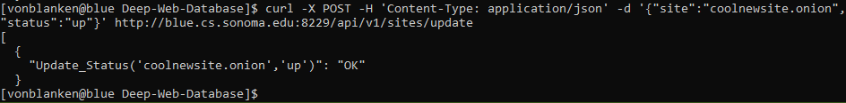

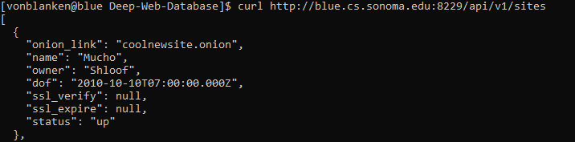

Path Name: Site Mirrors

Path: /api/v1/sites/mirrors/:site

Description: Lists all the mirrors (clones) of a domain.

Example: curl <http://blue.cs.sonoma.edu:8229/api/v1/sites/mirrors/http%3A%2F%2Fdarkfailllnkf4vf.onion>

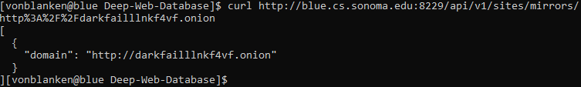

Path Name: Keyword Search

Path: /api/v1/search/:search

Description: Searches domain names and links for a string of characters (not case sensitive). Returns the domain on any matches.

Example: curl <http://blue.cs.sonoma.edu:8229/api/v1/search/dark>

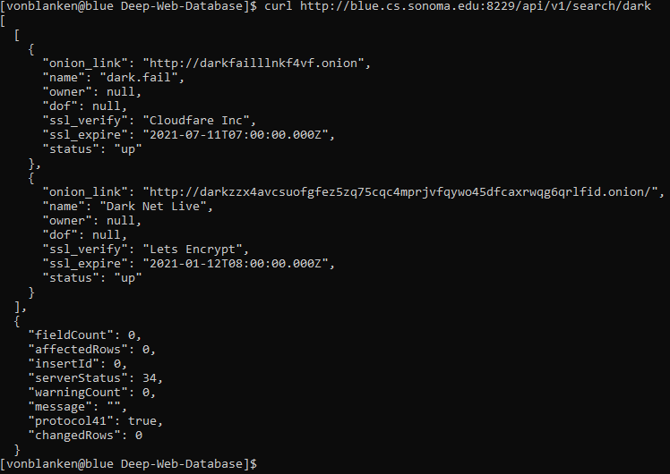

Path Name: Source Search

Path: /api/v1/search/source/:search

Description: Lists all domains linked to a specific source.

Example: curl http://blue.cs.sonoma.edu:8229/api/v1/search/source/https%3A%2F%2Fgithub.com%2Falecmuffett%2Freal-world-onion-sites

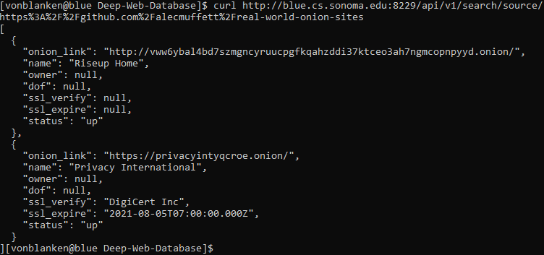

Path Name: Reference Search

Path: /api/v1/search/reference/:search

Description: Lists all domains vouched by a specific reference.

Example: curl <http://blue.cs.sonoma.edu:8229/api/v1/search/reference/https%3A%2F%2Friseup.net%2Fen%2Fsecurity%2Fnetwork-security%2Ftor%23riseups-tor-onion-services>

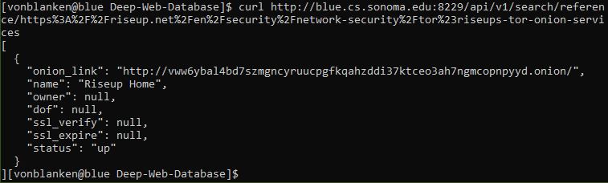

Path Name: Create Domain

Path: /api/v1/insert/domain

Description: Adds a new domain to the database.

Example: curl -X POST -H 'Content-Type: application/json' -d '{"onion_link":"kitchensinks.onion","name":"Kitchen Sink Central","owner":"Dink Sink","dof":"1999-11-11","status":"up"}' <http://blue.cs.sonoma.edu:8229/api/v1/insert/domain>

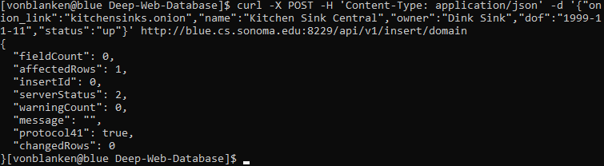

Path Name: Create Source

Path: /api/v1/insert/source

Description: Adds a new source to the database.

Example: curl -X POST -H 'Content-Type: application/json' -d '{"clearnet_link":"spookydarkweb.com","name":"Spooky Scary Websites"}' http://blue.cs.sonoma.edu:8229/api/v1/insert/source

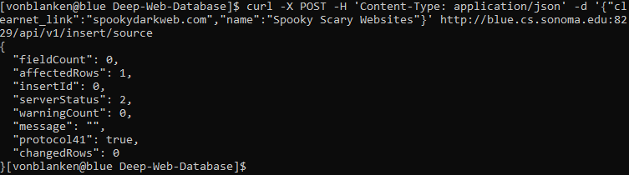

Path Name: Create Reference

Path: /api/v1/insert/reference

Description: Adds a new reference to the database.

Example: curl -X POST -H 'Content-Type: application/json' -d '{"clearnet_link":"opensource.com/pro-privacy-websites"}' <http://blue.cs.sonoma.edu:8229/api/v1/insert/reference>

